Windows environment variable setting

Step 1

* Open my computers

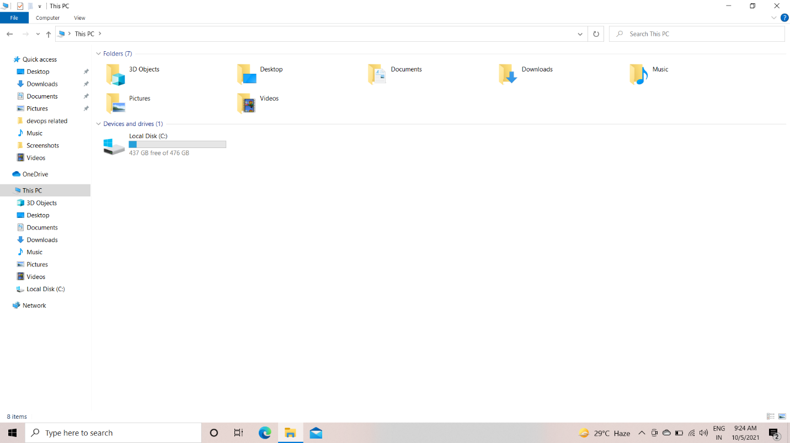

Step 2 => Right click on the screen

* Select properties

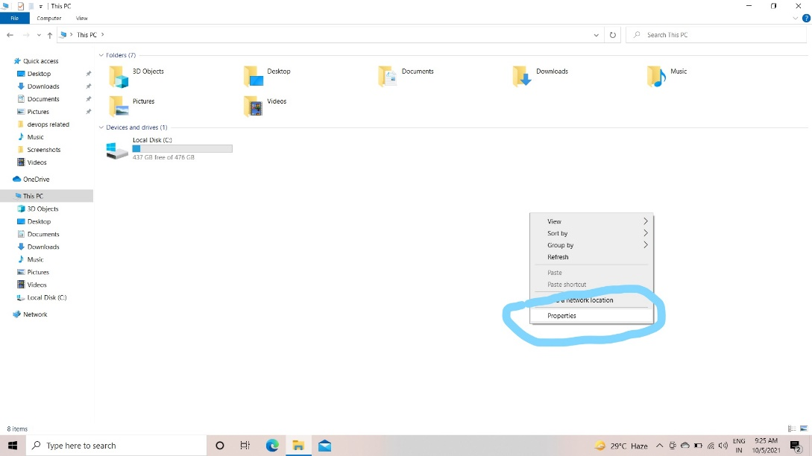

Step3

* go to advanced settings

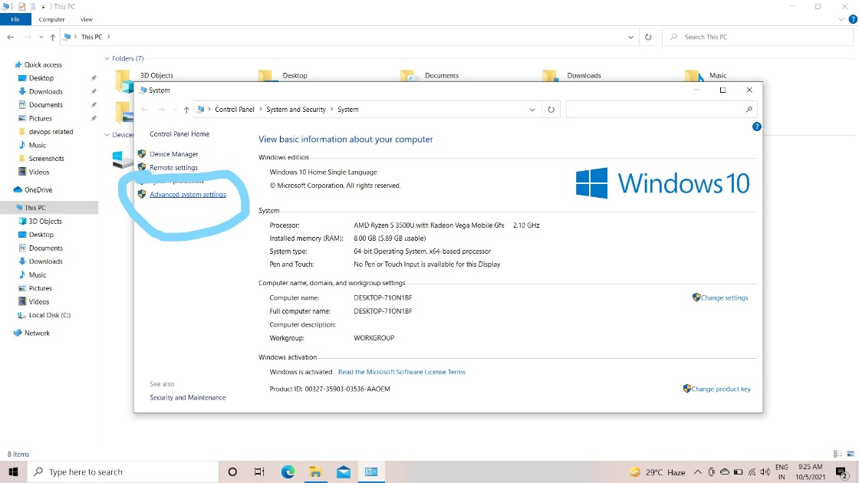

Step 4 => go to environment variables

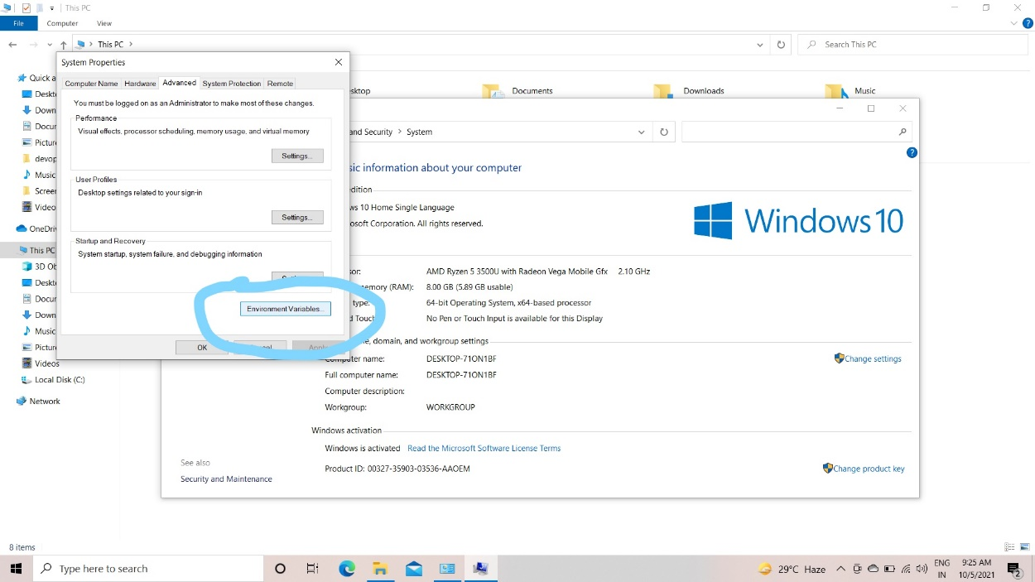

Step 5

* select path and open new

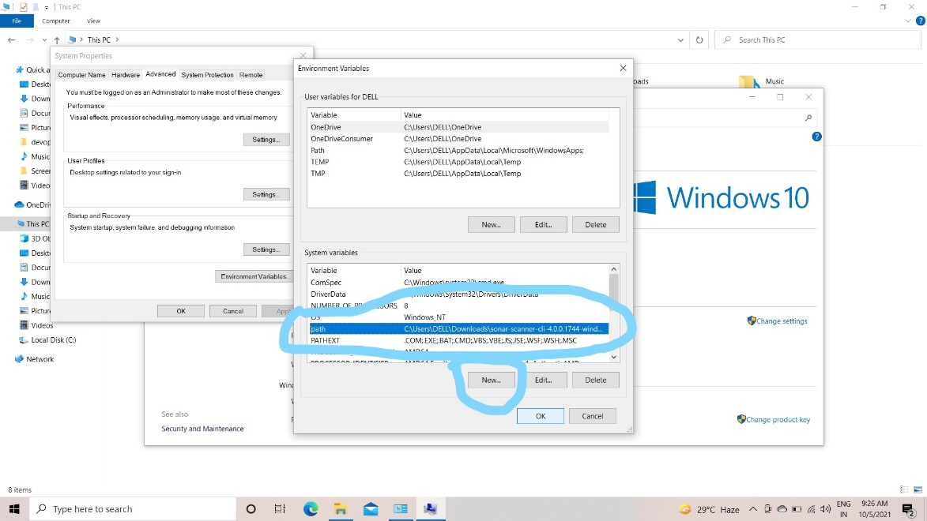

* last step
* enter your path like this

